

**Mehwish Kainat**

**Roll No BSEM-F20-026**

**Section: 5A**

**Subject: Mobile App Development**

**Submitted To: Muhammad Ahmed**

**Question#1**

*<?*xml version="1.0" encoding="utf-8"*?>*<RelativeLayout xmlns:android="http://schemas.android.com/apk/res/android"  
 xmlns:app="http://schemas.android.com/apk/res-auto"  
 xmlns:tools="http://schemas.android.com/tools"  
 android:layout_width="match_parent"  
 android:layout_height="match_parent"  
 tools:context=".MainActivity"  
 android:background="@drawable/background"  
 >  
 <TextView  
 android:layout_width="match_parent"  
 android:layout_height="wrap_content"  
 android:id="@+id/signup"  
 android:text="sign up"  
 android:textSize="35dp"  
 android:textStyle="bold"  
 android:textColor="@color/white"  
 android:gravity="center"  
 android:layout_margin="25dp"  
 />  
 <EditText  
 android:layout_width="match_parent"  
 android:layout_height="wrap_content"  
 android:id="@+id/username"  
 android:layout_below="@+id/signup"  
 android:background="#30ffffff"  
 android:hint="username"  
 android:textColorHint="@color/white"  
 android:textColor="@color/white"  
 android:layout_margin="10dp"  
 android:padding="20dp"  
 android:drawableLeft="@drawable/ic_baseline_person_24"  
 android:drawablePadding="20dp"  
 />  
  
 <EditText  
 android:id="@+id/email"  
 android:layout_width="match_parent"  
 android:layout_height="wrap_content"  
 android:layout_below="@+id/username"  
 android:layout_marginStart="10dp"  
 android:layout_marginTop="10dp"  
 android:layout_marginEnd="10dp"  
 android:layout_marginBottom="10dp"  
 android:background="#30ffffff"  
 android:drawableLeft="@drawable/ic_baseline_email_24"  
 android:drawablePadding="20dp"  
 android:hint="email"  
 android:padding="20dp"  
 android:textColor="@color/white"  
 android:textColorHint="@color/white" />  
  
 <EditText  
 android:id="@+id/Password"  
 android:layout_width="match_parent"  
 android:layout_height="wrap_content"  
 android:layout_below="@+id/email"  
 android:layout_marginStart="10dp"  
 android:layout_marginTop="10dp"  
 android:layout_marginEnd="10dp"  
 android:layout_marginBottom="10dp"  
 android:background="#30ffffff"  
 android:drawableLeft="@drawable/ic_baseline_lock_24"  
 android:drawablePadding="20dp"  
  
 android:hint="password"  
 android:padding="20dp"  
 android:textColor="@color/white"  
 android:textColorHint="@color/white" />  
  
 <EditText  
 android:id="@+id/rePassword"  
 android:layout_width="match_parent"  
 android:layout_height="wrap_content"  
 android:layout_below="@+id/Password"  
 android:layout_marginStart="10dp"  
 android:layout_marginTop="10dp"  
 android:layout_marginEnd="10dp"  
 android:layout_marginBottom="10dp"  
 android:background="#30ffffff"  
 android:drawableLeft="@drawable/ic_baseline_lock_open_24"  
 android:drawablePadding="20dp"  
  
 android:hint="Re-password"  
 android:padding="20dp"  
 android:textColor="@color/white"  
 android:textColorHint="@color/white" />  
  
 <Button  
 android:id="@+id/signupbtn"  
 android:layout_width="206dp"  
 android:layout_height="wrap_content"  
 android:layout_below="@id/rePassword"  
  
 android:layout_centerHorizontal="true"  
 android:layout_marginStart="20dp"  
 android:layout_marginTop="20dp"  
 android:layout_marginEnd="20dp"  
 android:background="@drawable/ic_baseline_lock_open_24"  
 android:text="Register"  
 android:textColor="#EFEFE6"  
 android:textSize="30dp" />  
  
 <TextView  
 android:id="@+id/info"  
 android:layout_width="wrap_content"  
 android:layout_height="wrap_content"  
 android:layout_below="@id/signupbtn"  
 android:layout_centerInParent="true"  
 android:text="or sign up with"  
 android:textColor="@color/white"  
 android:textSize="20dp" />  
 <LinearLayout  
 android:orientation="horizontal"  
 android:layout_width="match_parent"  
 android:layout_height="wrap_content"  
 android:id="@+id/socialicons"  
 android:layout_alignParentBottom="true"  
 android:gravity="center"  
 >  
  
  
  
 <ImageView  
 android:layout_width="48dp"  
 android:layout_height="48dp"  
 android:src="@drawable/face"  
 android:layout_margin="20dp"  
 />  
 <ImageView  
 android:layout_width="48dp"  
 android:layout_height="48dp"  
 android:src="@drawable/google"  
 android:layout_margin="20dp"  
 />  
 <ImageView  
 android:layout_width="48dp"  
 android:layout_height="48dp"  
 android:src="@drawable/skype"  
 android:layout_margin="20dp"  
 />  
  
  
  
  
 </LinearLayout>  
</RelativeLayout>

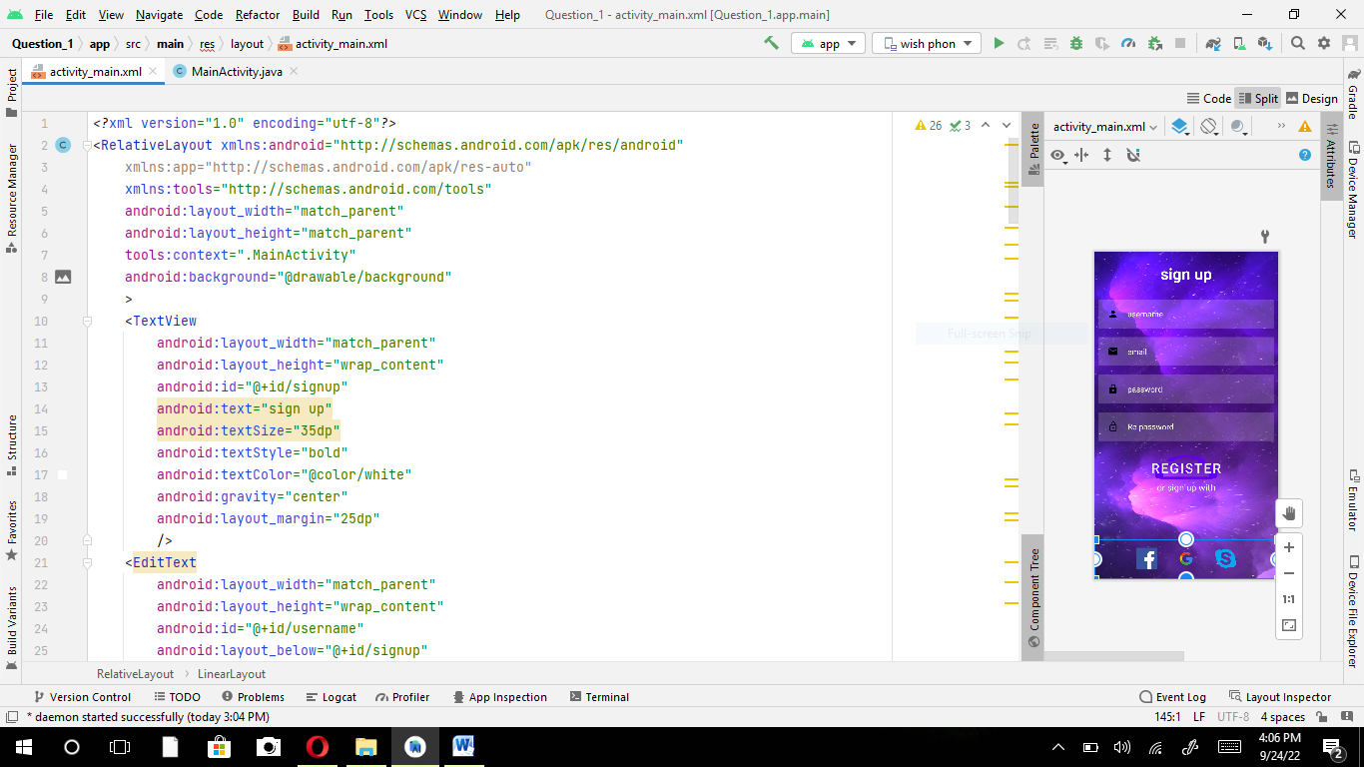

**Question#2**

**Part A:**

<?xml version="1.0" encoding="utf-8"?>

<LinearLayout xmlns:android="http://schemas.android.com/apk/res/android"

xmlns:app="http://schemas.android.com/apk/res-auto"

xmlns:tools="http://schemas.android.com/tools"

android:layout_width="match_parent"

android:layout_height="match_parent"

tools:context=".MainActivity"

android:weightSum="5"

android:orientation="vertical">

<LinearLayout

android:layout_weight="2"

android:layout_width="match_parent"

android:layout_height="0dp"

android:orientation="vertical"

android:gravity="center_horizontal"

>

<ImageView

android:layout_width="200dp"

android:layout_height="match_parent"

android:src="@drawable/Wish"/>

</LinearLayout>

<LinearLayout

android:layout_marginTop="5dp"

android:layout_weight="3"

android:layout_width="match_parent"

android:layout_height="0dp"

android:orientation="vertical"

android:background="@drawable/background"

>

<EditText

android:backgroundTint="@color/white"

android:textColor="@color/white"

android:drawablePadding="10dp"

android:drawableLeft="@drawable/ic_baseline_person_24"

android:layout_marginTop="80dp"

android:layout_marginStart="20dp"

android:layout_marginEnd="20dp"

android:layout_width="match_parent"

android:layout_height="wrap_content"

android:text="Username"/>

<EditText

android:backgroundTint="@color/white"

android:textColor="@color/white"

android:drawablePadding="10dp"

android:drawableLeft="@drawable/ic_baseline_lock_24"

android:layout_marginTop="15dp"

android:layout_marginStart="20dp"

android:layout_marginEnd="20dp"

android:layout_width="match_parent"

android:layout_height="wrap_content"

android:text="Password"/>

<TextView

android:textColor="@color/white"

android:layout_marginTop="10dp"

android:layout_marginEnd="20dp"

android:layout_width="wrap_content"

android:layout_height="wrap_content"

android:text="Forget Password?"

android:layout_gravity="right"/>

<Button

android:id="@+id/signin"

android:layout_width="279dp"

android:layout_height="65dp"

android:layout_marginStart="20dp"

android:layout_marginTop="80dp"

android:layout_marginEnd="20dp"

android:background="@drawable/btn"

android:shadowRadius="200"

android:text="Sign In"

android:textAllCaps="false"

android:textSize="18dp" />

<TextView

sign

android:layout_width="wrap_content"

android:layout_height="51dp"

android:layout_gravity="center_horizontal"

android:layout_marginTop="10dp"

android:text="New User?" signup now/>

</LinearLayout>

</LinearLayout>

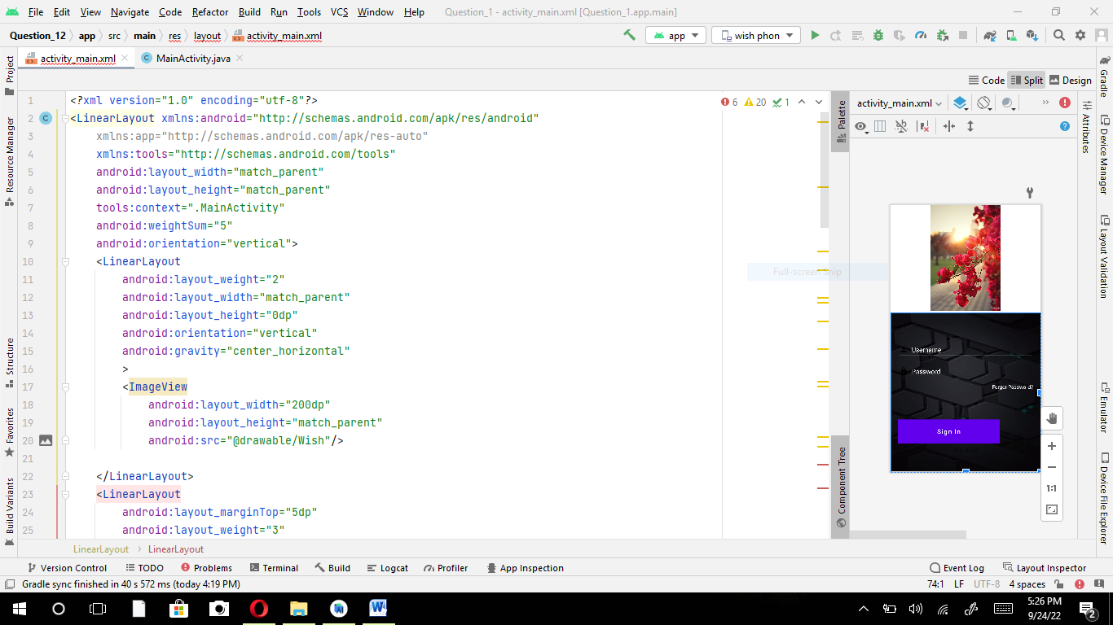

**Part B:**

<?xml version="1.0" encoding="utf-8"?>

<LinearLayout xmlns:android="http://schemas.android.com/apk/res/android"

xmlns:app="http://schemas.android.com/apk/res-auto"

xmlns:tools="http://schemas.android.com/tools"

android:layout_width="match_parent"

android:layout_height="match_parent"

android:orientation="vertical"

tools:context=".home">

<LinearLayout

android:padding="20dp"

android:layout_width="match_parent"

android:layout_height="wrap_content">

<ImageView

android:layout_width="40dp"

android:layout_height="40dp"

android:src="@drawable/ic_baseline_clear_all_24"/>

<ImageView

android:layout_weight="9"

android:layout_width="40dp"

android:layout_height="40dp"

/>

<ImageView

android:layout_weight="1"

android:layout_gravity="right"

android:layout_width="40dp"

android:layout_height="40dp"

android:src="@drawable/ic_baseline_shopping_cart_24"/>

</LinearLayout>

<androidx.cardview.widget.CardView

app:cardCornerRadius="20dp"

android:layout_width="match_parent"

android:layout_margin="10dp"

android:layout_height="wrap_content">

<EditText

android:background="#8AF1F1F1"

android:padding="10dp"

android:hint="Search"

android:drawableRight="@drawable/ic_baseline_mic_none_24"

android:drawableLeft="@drawable/ic_baseline_search_24"

android:paddingStart="10dp"

android:layout_width="match_parent"

android:layout_height="wrap_content"/>

</androidx.cardview.widget.CardView>

<LinearLayout

android:layout_width="match_parent"

android:layout_height="wrap_content"

android:orientation="horizontal">

<TextView

android:gravity="center"

android:textSize="20dp"

android:textStyle="bold"

android:layout_weight="1"

android:layout_width="0dp"

android:layout_height="wrap_content"

android:text="All"/>

<TextView

android:gravity="center"

android:textSize="20dp"

android:textStyle="bold"

android:layout_weight="1"

android:layout_width="0dp"

android:layout_height="wrap_content"

android:text="Small"/>

<TextView

android:gravity="center"

android:textSize="20dp"

android:textStyle="bold"

android:layout_weight="1"

android:layout_width="0dp"

android:layout_height="wrap_content"

android:text="Medium"/>

<TextView

android:gravity="center"

android:textSize="20dp"

android:textStyle="bold"

android:layout_weight="1"

android:layout_width="0dp"

android:layout_height="wrap_content"

android:text="Hanging"/>

</LinearLayout>

<LinearLayout

android:layout_weight="2"

android:orientation="vertical"

android:layout_width="match_parent"

android:layout_height="match_parent">

<LinearLayout

android:layout_margin="10dp"

android:layout_weight="1"

android:layout_width="match_parent"

android:layout_height="0dp"

android:orientation="horizontal">

<androidx.cardview.widget.CardView

android:layout_margin="10dp"

android:id="@+id/chamali"

app:cardCornerRadius="20dp"

android:layout_weight="1"

android:backgroundTint="#4CAF50"

android:layout_width="0dp"

android:layout_height="match_parent">

<LinearLayout

android:layout_width="match_parent"

android:layout_height="match_parent"

android:orientation="vertical">

<TextView

android:layout_marginTop="10dp"

android:layout_marginEnd="10dp"

android:layout_marginStart="10dp"

android:text="Indoor"

android:textColor="@color/white"

android:textSize="18dp"

android:drawableRight="@drawable/ic_baseline_bookmark_24"

android:layout_width="match_parent"

android:layout_height="wrap_content"/>

<ImageView

android:layout_gravity="center_horizontal"

android:layout_marginTop="5dp"

android:src="@drawable/cactus"

android:layout_width="150dp"

android:layout_height="140dp"/>

<TextView

android:layout_marginStart="10dp"

android:text="Ficas"

android:textColor="@color/white"

android:textSize="18dp"

android:textStyle="bold"

android:layout_width="wrap_content"

android:layout_height="wrap_content"/>

<TextView

android:layout_marginEnd="10dp"

android:layout_marginStart="10dp"

android:text="12.8 $"

android:textColor="@color/white"

android:textSize="18dp"

android:drawableRight="@drawable/ic_baseline_add_circle_outline_24"

android:layout_width="match_parent"

android:layout_height="wrap_content"/>

</LinearLayout>

</androidx.cardview.widget.CardView>

<androidx.cardview.widget.CardView

android:layout_margin="10dp"

app:cardCornerRadius="20dp"

android:layout_weight="1"

android:backgroundTint="#4CAF50"

android:layout_width="0dp"

android:layout_height="match_parent">

<LinearLayout

android:layout_width="match_parent"

android:layout_height="match_parent"

android:orientation="vertical">

<TextView

android:layout_marginTop="10dp"

android:layout_marginEnd="10dp"

android:layout_marginStart="10dp"

android:text="Indoor"

android:textColor="@color/white"

android:textSize="18dp"

android:drawableRight="@drawable/ic_baseline_bookmark_24"

android:layout_width="match_parent"

android:layout_height="wrap_content"/>

<ImageView

android:layout_gravity="center_horizontal"

android:layout_marginTop="5dp"

android:src="@drawable/samantha"

android:layout_width="150dp"

android:layout_height="140dp"/>

<TextView

android:layout_marginStart="10dp"

android:text="Samantha"

android:textColor="@color/white"

android:textSize="18dp"

android:textStyle="bold"

android:layout_width="wrap_content"

android:layout_height="wrap_content"/>

<TextView

android:layout_marginEnd="10dp"

android:layout_marginStart="10dp"

android:text="12.8 $"

android:textColor="@color/white"

android:textSize="18dp"

android:drawableRight="@drawable/ic_baseline_add_circle_outline_24"

android:layout_width="match_parent"

android:layout_height="wrap_content"/>

</LinearLayout>

</androidx.cardview.widget.CardView>

</LinearLayout>

<LinearLayout

android:layout_margin="10dp"

android:layout_weight="1"

android:layout_width="match_parent"

android:layout_height="0dp"

android:orientation="horizontal">

<androidx.cardview.widget.CardView

android:layout_margin="10dp"

app:cardCornerRadius="20dp"

android:layout_weight="1"

android:backgroundTint="#4CAF50"

android:layout_width="0dp"

android:layout_height="match_parent">

<LinearLayout

android:layout_width="match_parent"

android:layout_height="match_parent"

android:orientation="vertical">

<TextView

android:layout_marginTop="10dp"

android:layout_marginEnd="10dp"

android:layout_marginStart="10dp"

android:text="Indoor"

android:textColor="@color/white"

android:textSize="18dp"

android:drawableRight="@drawable/ic_baseline_bookmark_24"

android:layout_width="match_parent"

android:layout_height="wrap_content"/>

<ImageView

android:layout_gravity="center_horizontal"

android:layout_marginTop="5dp"

android:src="@drawable/ficas"

android:layout_width="150dp"

android:layout_height="140dp"/>

<TextView

android:layout_marginStart="10dp"

android:text="gulab"

android:textColor="@color/white"

android:textSize="18dp"

android:textStyle="bold"

android:layout_width="wrap_content"

android:layout_height="wrap_content"/>

<TextView

android:layout_marginEnd="10dp"

android:layout_marginStart="10dp"

android:text="12.8 $"

android:textColor="@color/white"

android:textSize="18dp"

android:drawableRight="@drawable/ic_baseline_add_circle_outline_24"

android:layout_width="match_parent"

android:layout_height="wrap_content"/>

</LinearLayout>

</androidx.cardview.widget.CardView>

<androidx.cardview.widget.CardView

android:layout_margin="10dp"

app:cardCornerRadius="20dp"

android:layout_weight="1"

android:backgroundTint="#4CAF50"

android:layout_width="0dp"

android:layout_height="match_parent">

<LinearLayout

android:layout_width="match_parent"

android:layout_height="match_parent"

android:orientation="vertical">

<TextView

android:layout_marginTop="10dp"

android:layout_marginEnd="10dp"

android:layout_marginStart="10dp"

android:text="Indoor"

android:textColor="@color/white"

android:textSize="18dp"

android:drawableRight="@drawable/ic_baseline_bookmark_24"

android:layout_width="match_parent"

android:layout_height="wrap_content"/>

<ImageView

android:layout_gravity="center_horizontal"

android:layout_marginTop="5dp"

android:src="@drawable/aloevera"

android:background="#4CAF50"

android:layout_width="150dp"

android:layout_height="140dp"/>

<TextView

android:layout_marginStart="10dp"

android:text="aloevera"

android:textColor="@color/white"

android:textSize="18dp"

android:textStyle="bold"

android:layout_width="wrap_content"

android:layout_height="wrap_content"/>

<TextView

android:layout_marginEnd="10dp"

android:layout_marginStart="10dp"

android:text="12.8 $"

android:textColor="@color/white"

android:textSize="18dp"

android:drawableRight="@drawable/ic_baseline_add_circle_outline_24"

android:layout_width="match_parent"

android:layout_height="wrap_content"/>

</LinearLayout>

</androidx.cardview.widget.CardView>

</LinearLayout>

</LinearLayout>

</LinearLayout>

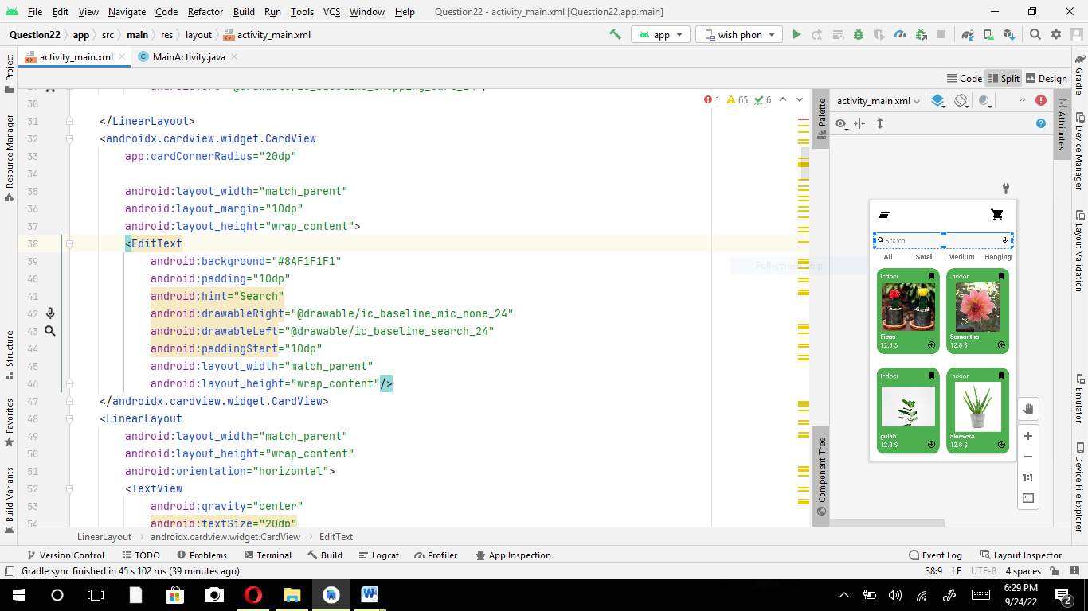

**Part C**

?xml version="1.0" encoding="utf-8"?>

<androidx.constraintlayout.widget.ConstraintLayout xmlns:android="http://schemas.android.com/apk/res/android"

xmlns:app="http://schemas.android.com/apk/res-auto"

xmlns:tools="http://schemas.android.com/tools"

android:layout_width="match_parent"

android:layout_height="match_parent"

tools:context=".MainActivity"

android:background="@color/white"

android:layout_gravity="center">

<ImageButton

android:id="@+id/imageButton"

android:layout_width="wrap_content"

android:layout_height="wrap_content"

android:layout_marginTop="20dp"

android:layout_marginEnd="16dp"

android:layout_marginRight="16dp"

android:background="@color/white"

android:src="@drawable/ic_baseline_favorite_24"

app:layout_constraintEnd_toEndOf="parent"

app:layout_constraintTop_toTopOf="parent"></ImageButton>

<TextView

android:id="@+id/textView4"

android:layout_width="wrap_content"

android:layout_height="wrap_content"

android:layout_marginTop="20dp"

android:background="@color/white"

android:text="Details"

android:textColor="@color/black"

android:textSize="20dp"

app:layout_constraintBottom_toTopOf="@+id/imageView"

app:layout_constraintEnd_toStartOf="@+id/imageButton"

app:layout_constraintHorizontal_bias="0.47"

app:layout_constraintStart_toEndOf="@+id/imageButton2"

app:layout_constraintTop_toTopOf="parent"

app:layout_constraintVertical_bias="0.063"></TextView>

<ImageButton

android:id="@+id/imageButton2"

android:layout_width="45dp"

android:layout_height="35dp"

android:layout_marginStart="16dp"

android:layout_marginLeft="16dp"

android:layout_marginTop="16dp"

android:background="@color/white"

android:src="@drawable/ic_baseline_arrow_back_24"

app:layout_constraintStart_toStartOf="parent"

app:layout_constraintTop_toTopOf="parent"></ImageButton>

<ImageView

android:id="@+id/imageView"

android:layout_width="284dp"

android:layout_height="321dp"

android:src="@drawable/aloevera"

app:layout_constraintBottom_toBottomOf="parent"

app:layout_constraintEnd_toEndOf="parent"

app:layout_constraintHorizontal_bias="0.496"

app:layout_constraintStart_toStartOf="parent"

app:layout_constraintTop_toTopOf="parent"

app:layout_constraintVertical_bias="0.175" />

<TextView

android:id="@+id/textView3"

android:layout_width="wrap_content"

android:layout_height="wrap_content"

android:text="Aloevera"

android:textColor="@color/black"

android:textSize="30dp"

android:textStyle="bold"

app:layout_constraintBottom_toBottomOf="parent"

app:layout_constraintEnd_toEndOf="parent"

app:layout_constraintHorizontal_bias="0.077"

app:layout_constraintStart_toStartOf="parent"

app:layout_constraintTop_toTopOf="parent"

app:layout_constraintVertical_bias="0.548" />

<TextView

android:id="@+id/textView2"

android:layout_width="wrap_content"

android:layout_height="wrap_content"

android:text="Regular Price 195$"

android:textColor="@color/black"

android:textSize="15dp"

app:layout_constraintBottom_toBottomOf="parent"

app:layout_constraintEnd_toEndOf="parent"

app:layout_constraintHorizontal_bias="0.055"

app:layout_constraintStart_toStartOf="parent"

app:layout_constraintTop_toTopOf="parent"

app:layout_constraintVertical_bias="0.582"></TextView>

<TextView

android:id="@+id/textView"

android:layout_width="wrap_content"

android:layout_height="wrap_content"

android:padding="20dp"

android:text="It is long established fact that a leader will be distracted

by the readable content of a page when looking at it's layout "

android:textColor="@color/black"

android:textSize="20dp"

app:layout_constraintBottom_toBottomOf="parent"

app:layout_constraintEnd_toEndOf="parent"

app:layout_constraintHorizontal_bias="1.0"

app:layout_constraintStart_toStartOf="parent"

app:layout_constraintTop_toTopOf="parent"

app:layout_constraintVertical_bias="0.84" />

<Button

android:id="@+id/button2"

android:layout_width="match_parent"

android:layout_height="wrap_content"

android:layout_marginBottom="40dp"

android:background="#698F3D"

android:text="BUY now"

android:textColor="@color/white"

android:textSize="20dp"

app:layout_constraintBottom_toBottomOf="parent"

app:layout_constraintEnd_toEndOf="parent"

app:layout_constraintHorizontal_bias="0.0"

app:layout_constraintStart_toStartOf="parent"/>

<RatingBar

android:id="@+id/ratingBar"

android:layout_width="233dp"

android:layout_height="69dp"

android:background="#07FFFFFF"

android:rating="5"

android:outlineAmbientShadowColor="@color/black"

app:layout_constraintBottom_toBottomOf="parent"

app:layout_constraintEnd_toEndOf="parent"

app:layout_constraintHorizontal_bias="1.0"

app:layout_constraintStart_toStartOf="parent"

app:layout_constraintTop_toTopOf="parent"

app:layout_constraintVertical_bias="0.631"/>

<Button

android:id="@+id/decrease"

android:layout_width="37dp"

android:layout_height="35dp"

android:layout_marginStart="16dp"

android:layout_marginLeft="16dp"

android:background="@color/teal_700"

android:text="-"

android:textStyle="bold"

app:layout_constraintBottom_toBottomOf="parent"

app:layout_constraintStart_toStartOf="parent"

app:layout_constraintTop_toTopOf="parent"

app:layout_constraintVertical_bias="0.662" />

<TextView

android:id="@+id/integer_number"

android:layout_width="wrap_content"

android:layout_height="wrap_content"

android:text="1"

android:textColor="@color/black"

android:textSize="30dp"

android:textStyle="bold"

app:layout_constraintBottom_toBottomOf="parent"

app:layout_constraintEnd_toStartOf="@+id/increase"

app:layout_constraintHorizontal_bias="0.583"

app:layout_constraintStart_toEndOf="@+id/decrease"

app:layout_constraintTop_toTopOf="parent"

app:layout_constraintVertical_bias="0.66" />

<Button

android:id="@+id/increase"

android:layout_width="37dp"

android:layout_height="35dp"

android:layout_marginEnd="232dp"

android:layout_marginRight="232dp"

android:background="@color/teal_700"

android:text="+"

app:layout_constraintBottom_toBottomOf="parent"

app:layout_constraintEnd_toEndOf="parent"

app:layout_constraintTop_toTopOf="parent"

app:layout_constraintVertical_bias="0.662" />

</androidx.constraintlayout.widget.ConstraintLayout>

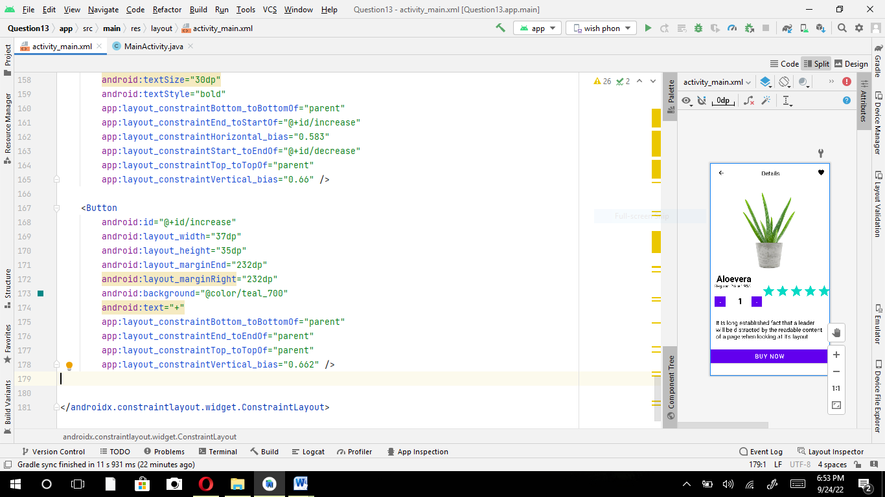

**Question#3**

?xml version="1.0" encoding="utf-8"?

<LinearLayout xmlns:android="http://schemas.android.com/apk/res/android"

xmlns:tools="http://schemas.android.com/tools"

android:orientation="horizontal"

android:layout_width="match_parent"

android:layout_height="match_parent"

tools:context=".MainActivity"

android:weightSum="3"

android:background="@drawable/back">

<LinearLayout

android:gravity="center_horizontal"

android:layout_width="0dp"

android:layout_height="match_parent"

android:layout_weight="1"

android:orientation="vertical">

<ImageView

android:layout_width="wrap_content"

android:layout_height="97dp"

android:layout_margin="20dp"

android:src="@drawable/facebook" />

<TextView

android:layout_width="wrap_content"

android:layout_height="wrap_content"

android:text="Instagram"

android:textColor="@color/white"/>

<ImageView

android:layout_width="wrap_content"

android:layout_height="87dp"

android:layout_margin="20dp"

android:src="@drawable/setting" />

<TextView

android:layout_width="wrap_content"

android:layout_height="wrap_content"

android:text="Setting"

android:textColor="@color/white"/>

<ImageView

android:layout_width="wrap_content"

android:layout_height="78dp"

android:layout_margin="20dp"

android:src="@drawable/google" />

<TextView

android:layout_width="wrap_content"

android:layout_height="wrap_content"

android:text="Google"

android:textColor="@color/white"/>

<ImageView

android:layout_width="wrap_content"

android:layout_height="72dp"

android:layout_margin="20dp"

android:src="@drawable/twitter" />

<TextView

android:layout_width="wrap_content"

android:layout_height="wrap_content"

android:text="Skype"

android:textColor="@color/white"/>

<ImageView

android:layout_width="wrap_content"

android:layout_height="84dp"

android:layout_margin="20dp"

android:src="@drawable/insta" />

<TextView

android:layout_width="wrap_content"

android:layout_height="wrap_content"

android:text="Instagram"

android:textColor="@color/white" />

</LinearLayout>

<LinearLayout

android:gravity="center_horizontal"

android:layout_width="0dp"

android:layout_height="match_parent"

android:layout_weight="1"

android:orientation="vertical">

<ImageView

android:layout_width="wrap_content"

android:layout_height="93dp"

android:layout_margin="20dp"

android:src="@drawable/masenger" />

<TextView

android:layout_width="wrap_content"

android:layout_height="wrap_content"

android:text="Messenger"

android:textColor="@color/white" />

<ImageView

android:layout_width="wrap_content"

android:layout_height="91dp"

android:layout_margin="20dp"

android:src="@drawable/chrome" />

<TextView

android:layout_width="wrap_content"

android:layout_height="wrap_content"

android:text="Chrome"

android:textColor="@color/white"/>

<ImageView

android:layout_width="wrap_content"

android:layout_height="84dp"

android:layout_margin="20dp"

android:src="@drawable/phone" />

<TextView

android:layout_width="wrap_content"

android:layout_height="wrap_content"

android:text="Phone"

android:textColor="@color/white"/>

<ImageView

android:layout_width="wrap_content"

android:layout_height="68dp"

android:layout_margin="20dp"

android:src="@drawable/game" />

<TextView

android:layout_width="wrap_content"

android:layout_height="wrap_content"

android:text="Game"

android:textColor="@color/white"/>

<ImageView

android:layout_width="wrap_content"

android:layout_height="84dp"

android:layout_margin="20dp"

android:src="@drawable/music" />

<TextView

android:layout_width="wrap_content"

android:layout_height="wrap_content"

android:text="Music"

android:textColor="@color/white"/>

</LinearLayout>

<LinearLayout

android:layout_width="0dp"

android:layout_height="match_parent"

android:layout_weight="1"

android:gravity="center_horizontal"

android:orientation="vertical">

<ImageView

android:layout_width="wrap_content"

android:layout_height="93dp"

android:layout_margin="20dp"

android:src="@drawable/camera" />

<TextView

android:layout_width="wrap_content"

android:layout_height="wrap_content"

android:text="Camera"

android:textColor="@color/white" />

<ImageView

android:layout_width="wrap_content"

android:layout_height="80dp"

android:layout_margin="20dp"

android:src="@drawable/snapchat" />

<TextView

android:layout_width="wrap_content"

android:layout_height="wrap_content"

android:text="Snapchat"

android:textColor="@color/white" />

<ImageView

android:layout_width="wrap_content"

android:layout_height="89dp"

android:layout_margin="20dp"

android:src="@drawable/watsapp" />

<ImageView

android:layout_width="68dp"

android:layout_height="85dp"

android:layout_margin="20dp"

android:src="@drawable/message" />

<TextView

android:layout_width="wrap_content"

android:layout_height="wrap_content"

android:text="Watsapp"

android:textColor="@color/white" />

<ImageView

android:layout_width="wrap_content"

android:layout_height="102dp"

android:margin="20dp"

android:src="@drawable/telegram" />

<TextView

android:layout_width="wrap_content"

android:layout_height="wrap_content"

android:text="Telegram"

android:textColor="@color/white" />

<TextView

android:layout_width="wrap_content"

android:layout_height="wrap_content"

android:text="Message"

android:textColor="@color/white" />

</LinearLayout>

<LinearLayout

android:layout_width="93dp"

android:layout_height="match_parent"

android:layout_weight="1"

android:gravity="center_horizontal"

android:orientation="vertical">

<ImageView

android:layout_width="wrap_content"

android:layout_height="74dp"

android:layout_margin="20dp"

android:src="@drawable/youtube" />

<TextView

android:layout_width="wrap_content"

android:layout_height="wrap_content"

android:text="Youtube"

android:textColor="@color/white" />

<ImageView

android:layout_width="wrap_content"

android:layout_height="89dp"

android:layout_margin="20dp"

android:src="@drawable/playstore" />

<TextView

android:layout_width="wrap_content"

android:layout_height="wrap_content"

android:text="Playstore"

android:textColor="@color/white" />

<ImageView

android:layout_width="wrap_content"

android:layout_height="89dp"

android:layout_margin="20dp"

android:src="@drawable/album" />

<TextView

android:layout_width="wrap_content"

android:layout_height="wrap_content"

android:text="Album"

android:textColor="@color/white" />

<ImageView

android:layout_width="wrap_content"

android:layout_height="89dp"

android:layout_margin="20dp"

android:src="@drawable/clock" />

<TextView

android:layout_width="wrap_content"

android:layout_height="wrap_content"

android:text="Clock"

android:textColor="@color/white" />

<ImageView

android:layout_width="70dp"

android:layout_height="67dp"

android:layout_margin="20dp"

android:src="@drawable/Notes" />

<TextView

android:layout_width="wrap_content"

android:layout_height="wrap_content"

android:text="Notes"

android:textColor="@color/white" />

</LinearLayout>

</LinearLayout>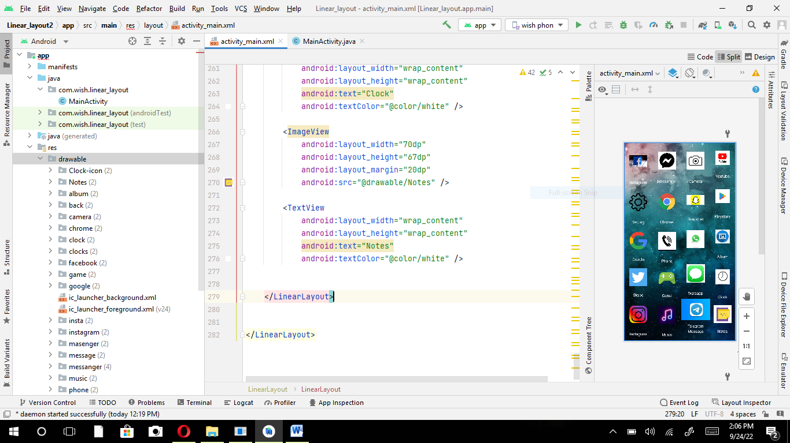

**Question#4**

**Part A**

<?xml version="1.0" encoding="utf-8"?>

<androidx.constraintlayout.widget.ConstraintLayout xmlns:android="http://schemas.android.com/apk/res/android"

xmlns:app="http://schemas.android.com/apk/res-auto"

xmlns:tools="http://schemas.android.com/tools"

android:layout_width="match_parent"

android:layout_height="match_parent"

android:background="@drawable/background"

tools:context=".MainActivity">

<ImageView

android:layout_width="120dp"

android:layout_height="100dp"

android:background="@drawable/pie2"

tools:layout_editor_absoluteX="42dp"

tools:layout_editor_absoluteY="29dp" />

<ImageView

android:layout_width="100dp"

android:layout_height="100dp"

android:background="@drawable/gift"

tools:layout_editor_absoluteX="18dp"

tools:layout_editor_absoluteY="598dp" />

<ImageView

android:layout_width="100dp"

android:layout_height="100dp"

android:background="@drawable/rocket"

tools:layout_editor_absoluteX="16dp"

tools:layout_editor_absoluteY="482dp" />

<ImageView

android:layout_width="78dp"

android:layout_height="75dp"

android:background="@drawable/store"

tools:layout_editor_absoluteX="0dp"

tools:layout_editor_absoluteY="352dp" />

<ImageView

android:layout_width="78dp"

android:layout_height="75dp"

android:background="@drawable/shopping"

tools:layout_editor_absoluteX="204dp"

tools:layout_editor_absoluteY="352dp" />

<ImageView

android:layout_width="78dp"

android:layout_height="75dp"

android:background="@drawable/collection"

tools:layout_editor_absoluteX="96dp"

tools:layout_editor_absoluteY="352dp" />

<ImageView

android:layout_width="78dp"

android:layout_height="75dp"

android:background="@drawable/dining"

tools:layout_editor_absoluteX="311dp"

tools:layout_editor_absoluteY="352dp" />

<TextView

android:id="@+id/s1"

android:layout_width="25dp"

android:layout_height="100dp"

android:background="@drawable/shape"

app:layout_constraintBottom_toBottomOf="parent"

app:layout_constraintEnd_toEndOf="parent"

app:layout_constraintHorizontal_bias="0.075"

app:layout_constraintStart_toStartOf="parent"

app:layout_constraintTop_toTopOf="parent"

app:layout_constraintVertical_bias="0.326" />

<TextView

android:id="@+id/s1"

android:layout_width="25dp"

android:layout_height="69dp"

android:background="@drawable/shape2"

app:layout_constraintBottom_toBottomOf="parent"

app:layout_constraintEnd_toEndOf="parent"

app:layout_constraintHorizontal_bias="0.886"

app:layout_constraintStart_toStartOf="parent"

app:layout_constraintTop_toTopOf="parent"

app:layout_constraintVertical_bias="0.358" />

<TextView

android:id="@+id/s1"

android:layout_width="25dp"

android:layout_height="69dp"

android:background="@drawable/shape3"

app:layout_constraintBottom_toBottomOf="parent"

app:layout_constraintEnd_toEndOf="parent"

app:layout_constraintHorizontal_bias="0.746"

app:layout_constraintStart_toStartOf="parent"

app:layout_constraintTop_toTopOf="parent"

app:layout_constraintVertical_bias="0.358" />

<TextView

android:id="@+id/s1"

android:layout_width="25dp"

android:layout_height="45dp"

android:background="@drawable/shape4"

app:layout_constraintBottom_toBottomOf="parent"

app:layout_constraintEnd_toEndOf="parent"

app:layout_constraintHorizontal_bias="0.626"

app:layout_constraintStart_toStartOf="parent"

app:layout_constraintTop_toTopOf="parent"

app:layout_constraintVertical_bias="0.38" />

<TextView

android:id="@+id/s1"

android:layout_width="25dp"

android:layout_height="30dp"

android:background="@drawable/shape5"

app:layout_constraintBottom_toBottomOf="parent"

app:layout_constraintEnd_toEndOf="parent"

app:layout_constraintHorizontal_bias="0.481"

app:layout_constraintStart_toStartOf="parent"

app:layout_constraintTop_toTopOf="parent"

app:layout_constraintVertical_bias="0.393" />

<TextView

android:id="@+id/s1"

android:layout_width="25dp"

android:layout_height="100dp"

android:background="@drawable/shape6"

app:layout_constraintBottom_toBottomOf="parent"

app:layout_constraintEnd_toEndOf="parent"

app:layout_constraintHorizontal_bias="0.321"

app:layout_constraintStart_toStartOf="parent"

app:layout_constraintTop_toTopOf="parent"

app:layout_constraintVertical_bias="0.326" />

<TextView

android:id="@+id/s1"

android:layout_width="25dp"

android:layout_height="50dp"

android:background="@drawable/shape7"

app:layout_constraintBottom_toBottomOf="parent"

app:layout_constraintEnd_toEndOf="parent"

app:layout_constraintHorizontal_bias="0.212"

app:layout_constraintStart_toStartOf="parent"

app:layout_constraintTop_toTopOf="parent"

app:layout_constraintVertical_bias="0.375" />

<TextView

android:id="@+id/textView"

android:layout_width="wrap_content"

android:layout_height="wrap_content"

android:text="MO"

tools:layout_editor_absoluteX="29dp"

tools:layout_editor_absoluteY="306dp" />

<TextView

android:id="@+id/textView2"

android:layout_width="wrap_content"

android:layout_height="wrap_content"

android:text="TU"

tools:layout_editor_absoluteX="82dp"

tools:layout_editor_absoluteY="306dp" />

<TextView

android:id="@+id/textView3"

android:layout_width="wrap_content"

android:layout_height="wrap_content"

android:text="WE"

tools:layout_editor_absoluteX="124dp"

tools:layout_editor_absoluteY="306dp" />

<TextView

android:id="@+id/textView4"

android:layout_width="wrap_content"

android:layout_height="wrap_content"

android:text="TH"

tools:layout_editor_absoluteX="186dp"

tools:layout_editor_absoluteY="306dp" />

<TextView

android:id="@+id/textView5"

android:layout_width="wrap_content"

android:layout_height="wrap_content"

android:text="FR"

tools:layout_editor_absoluteX="242dp"

tools:layout_editor_absoluteY="306dp" />

<TextView

android:id="@+id/textView6"

android:layout_width="wrap_content"

android:layout_height="wrap_content"

android:text="SA"

tools:layout_editor_absoluteX="288dp"

tools:layout_editor_absoluteY="306dp" />

<TextView

android:id="@+id/textView7"

android:layout_width="wrap_content"

android:layout_height="wrap_content"

android:text="SU"

tools:layout_editor_absoluteX="342dp"

tools:layout_editor_absoluteY="306dp" />

<TextView

android:id="@+id/textView8"

android:layout_width="wrap_content"

android:layout_height="wrap_content"

android:text="Store"

android:textColor="@color/black"

tools:layout_editor_absoluteX="29dp"

tools:layout_editor_absoluteY="427dp" />

<TextView

android:id="@+id/textView9"

android:layout_width="wrap_content"

android:layout_height="wrap_content"

android:text="Collection"

android:textColor="@color/black"

tools:layout_editor_absoluteX="100dp"

tools:layout_editor_absoluteY="427dp" />

<TextView

android:id="@+id/textView10"

android:layout_width="wrap_content"

android:layout_height="wrap_content"

android:text="Shopping"

android:textColor="@color/black"

tools:layout_editor_absoluteX="211dp"

tools:layout_editor_absoluteY="427dp" />

<TextView

android:id="@+id/textView11"

android:layout_width="wrap_content"

android:layout_height="wrap_content"

android:text="Cart Dining"

android:textColor="@color/black"

tools:layout_editor_absoluteX="313dp"

tools:layout_editor_absoluteY="427dp" />

<TextView

android:id="@+id/textView12"

android:layout_width="wrap_content"

android:layout_height="wrap_content"

android:text="Network Fee"

android:textColor="@color/black"

android:textSize="25sp"

android:textStyle="bold"

tools:layout_editor_absoluteX="162dp"

tools:layout_editor_absoluteY="482dp" />

<TextView

android:id="@+id/textView13"

android:layout_width="wrap_content"

android:layout_height="wrap_content"

android:text="Welfare"

android:textColor="@color/black"

android:textSize="25sp"

android:textStyle="bold"

tools:layout_editor_absoluteX="162dp"

tools:layout_editor_absoluteY="609dp" />

<TextView

android:id="@+id/textView14"

android:layout_width="wrap_content"

android:layout_height="wrap_content"

android:text="26$"

android:textColor="#04557A"

android:textSize="25sp"

android:textStyle="bold"

tools:layout_editor_absoluteX="356dp"

tools:layout_editor_absoluteY="494dp" />

<TextView

android:id="@+id/textView15"

android:layout_width="wrap_content"

android:layout_height="wrap_content"

android:text="255$"

android:textColor="#084C6A"

android:textSize="25sp"

android:textStyle="bold"

tools:layout_editor_absoluteX="349dp"

tools:layout_editor_absoluteY="609dp" />

<TextView

android:id="@+id/textView16"

android:layout_width="wrap_content"

android:layout_height="wrap_content"

android:text="Used in May"

tools:layout_editor_absoluteX="165dp"

tools:layout_editor_absoluteY="537dp" />

<TextView

android:id="@+id/textView17"

android:layout_width="wrap_content"

android:layout_height="wrap_content"

android:text="Special Recommendation"

tools:layout_editor_absoluteX="165dp"

tools:layout_editor_absoluteY="656dp" />

<TextView

android:id="@+id/textView18"

android:layout_width="wrap_content"

android:layout_height="wrap_content"

android:text="Available Balance"

android:textStyle="bold"

android:textColor="@color/black"

android:textSize="25sp"

tools:layout_editor_absoluteX="211dp"

tools:layout_editor_absoluteY="29dp" />

<TextView

android:id="@+id/textView19"

android:layout_width="wrap_content"

android:layout_height="wrap_content"

android:text="12,126$"

android:textStyle="bold"

android:textColor="#04557A"

android:textSize="25sp"

tools:layout_editor_absoluteX="296dp"

tools:layout_editor_absoluteY="78dp" />

</androidx.constraintlayout.widget.ConstraintLayout>

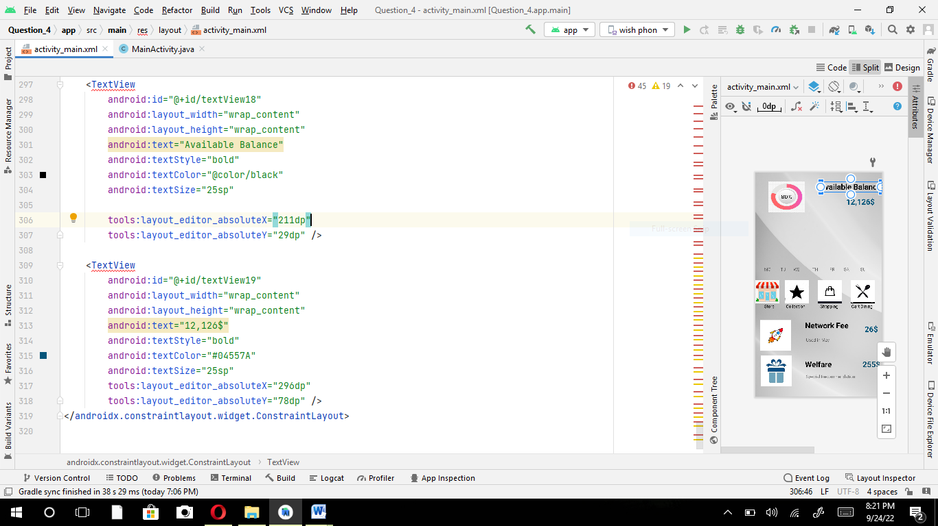

**Part B**

<?xml version="1.0" encoding="utf-8"?>

<androidx.constraintlayout.widget.ConstraintLayout xmlns:android="http://schemas.android.com/apk/res/android"

xmlns:app="http://schemas.android.com/apk/res-auto"

xmlns:tools="http://schemas.android.com/tools"

android:layout_width="match_parent"

android:layout_height="match_parent"

tools:context=".MainActivity">

<Button

android:id="@+id/textView3"

android:layout_width="200dp"

android:layout_height="150dp"

android:background="@color/white"

android:text="6220***789

EXP DATE 12/23"

android:textAlignment="center"

android:textColor="#000000"

android:textSize="25sp"

android:textStyle="normal"

app:backgroundTint="#abd7eb"

app:layout_constraintBottom_toBottomOf="parent"

app:layout_constraintEnd_toEndOf="parent"

app:layout_constraintHorizontal_bias="0.985"

app:layout_constraintStart_toStartOf="parent"

app:layout_constraintTop_toTopOf="parent"

app:layout_constraintVertical_bias="0.161" />

<Button

android:id="@+id/textView3"

android:layout_width="200dp"

android:layout_height="150dp"

android:background="@color/pink"

android:text="6220***546

Exp DATE

12/23"

android:textAlignment="center"

android:textColor="#000000"

android:textSize="25sp"

android:textStyle="normal"

app:backgroundTint="#ffb8bf"

app:layout_constraintBottom_toBottomOf="parent"

app:layout_constraintEnd_toEndOf="parent"

app:layout_constraintHorizontal_bias="0.0"

app:layout_constraintStart_toStartOf="parent"

app:layout_constraintTop_toTopOf="parent"

app:layout_constraintVertical_bias="0.161" />

<ImageView

android:id="@+id/imageView2"

android:layout_width="200dp"

android:layout_height="150dp"

android:background="@drawable/card"

tools:layout_editor_absoluteX="211dp"

tools:layout_editor_absoluteY="252dp" />

<ImageView

android:id="@+id/imageView2"

android:layout_width="300dp"

android:layout_height="100dp"

android:background="@drawable/request"

tools:layout_editor_absoluteX="57dp"

tools:layout_editor_absoluteY="635dp" />

<Button

android:id="@+id/textView3"

android:layout_width="200dp"

android:layout_height="150dp"

android:background="@color/white"

android:text="7089**789

Exp date

12/23"

android:textAlignment="Left"

android:textColor="#000000"

android:textSize="25sp"

android:textStyle="normal"

app:backgroundTint="#FFCC99"

app:layout_constraintBottom_toBottomOf="parent"

app:layout_constraintEnd_toEndOf="parent"

app:layout_constraintHorizontal_bias="0.0"

app:layout_constraintStart_toStartOf="parent"

app:layout_constraintTop_toTopOf="parent"

app:layout_constraintVertical_bias="0.433" />

<TextView

android:id="@+id/textView"

android:layout_width="150dp"

android:layout_height="80dp"

android:text="CARDS"

android:textColor="#000000"

android:textSize="45sp"

android:textStyle="bold"

app:layout_constraintEnd_toEndOf="parent"

app:layout_constraintHorizontal_bias="0.068"

app:layout_constraintStart_toStartOf="parent"

tools:layout_editor_absoluteY="26dp" />

<TextView

android:id="@+id/textView2"

android:layout_width="wrap_content"

android:layout_height="wrap_content"

android:text="LOANS"

android:textColor="#000000"

android:textSize="45sp"

android:textStyle="bold"

tools:layout_editor_absoluteX="16dp"

tools:layout_editor_absoluteY="411dp" />

<TextView

android:id="@+id/s1"

android:layout_width="match_parent"

android:layout_height="150dp"

android:layout_marginStart="8dp"

android:layout_marginLeft="8dp"

android:background="@drawable/shape"

android:textSize="20dp"

app:layout_constraintBottom_toBottomOf="parent"

app:layout_constraintStart_toStartOf="parent"

app:layout_constraintTop_toTopOf="parent"

app:layout_constraintVertical_bias="0.81" />

<ImageView

android:id="@+id/imageView2"

android:layout_width="150dp"

android:layout_height="150dp"

android:background="@drawable/loan"

tools:layout_editor_absoluteX="258dp"

tools:layout_editor_absoluteY="471dp" />

<TextView

android:id="@+id/textView4"

android:layout_width="wrap_content"

android:layout_height="wrap_content"

android:text="student loan"

android:textSize="20sp"

tools:layout_editor_absoluteX="57dp"

tools:layout_editor_absoluteY="492dp" />

<TextView

android:id="@+id/textView5"

android:layout_width="wrap_content"

android:layout_height="wrap_content"

android:text="12,1265$"

android:textColor="#000000"

android:textSize="30sp"

tools:layout_editor_absoluteX="57dp"

tools:layout_editor_absoluteY="519dp" />

<TextView

android:id="@+id/textView6"

android:layout_width="wrap_content"

android:layout_height="wrap_content"

android:text="student loan"

android:textSize="20sp"

tools:layout_editor_absoluteX="69dp"

tools:layout_editor_absoluteY="559dp" />

<TextView

android:id="@+id/textView7"

android:layout_width="wrap_content"

android:layout_height="wrap_content"

android:text="Amount 2,160$"

android:textColor="#000000"

android:textSize="30sp"

tools:layout_editor_absoluteX="28dp"

tools:layout_editor_absoluteY="586dp" />

</androidx.constraintlayout.widget.ConstraintLayout>

